Management Tool Software Requirements

1. User Requirements
   1. The SMBIOS type 2 System information asset tag is synced with motherboard (PDB) FRU asset tag.
   2. The SMBIOS type 2 System information serial number is synced with motherboard (PDB) FRU board serial number.
   3. The SMBIOS type 3 Chassis Information asset tag is synced with Chassis FRU asset tag.
   4. The SMBIOS type 3 Chassis information serial number is synced with Chassis FRU board serial number.
   5. There is the case motherboard is replaced. BMC should read the Chassis FRU serial number. Check the motherboard FRU chassis serial number, if not same, program the motherboard chassis FRU chassis serial number same to the Chassis FRU chassis serial number.

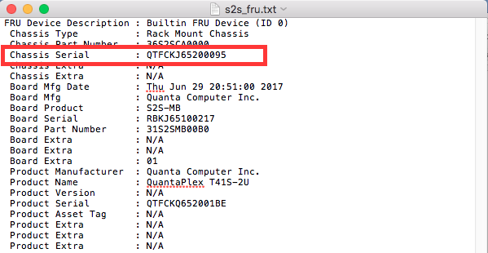

* 1. Asset tag/Serial number can be update OOB.
  2. Group flash BIOS/BMC OOB.
  3. Change Power management OOB, we can support this feature by sending ipmitool, SMC do support it by their tool, slightly easier to maneuver over it.

|  |  |
| --- | --- |
|  | SMC |
| Change power management | Homemade IPMI  Usage: **nm pstate [value]**  Example Output:      Current P-State   = 7      Number of P-State = 8  Nm tstate |

* 1. BMC LDAP/AD/Radius authentication supported. Customer customized the username/password when they place the order, it will be easier for them to management the credential centralized.
  2. NTP support.

Including feature about: Enable/disable, TimeZone, Daylight saving, Server configuration.

* 1. DDNS support – low priority, Customer can create their own local DNS and assign the name of it. At least Dropbox had similar way.
  2. Rsyslog support. – Personal opinion, This is a tool to management lots of server in Data center.
  3. Smtp support. –SMC support this feature.